

Team Leader – Development Management (Post 2144, 2120, 2211)

Service Area
Planning

Manager/Team Leader
Development Manager

Direct reports
3/4

Total Managed
3/4

Purpose of the Role

The post holder is required to lead a team in the day to day delivery of services, to deputise for the Development Manager when the latter is unavailable and handle a caseload of applications. The management of the team is a crucial part of this position, providing support, guidance and mentoring.

Key Result Areas

- To manage the day to day workload of the team to ensure the smooth processing of planning applications in accordance with the legislatives requirements and the Council’s policies, procedures and practices.
- To manage, motivate and develop staff in order to achieve successful outcomes in terms of the determination of planning applications in accordance with the Council’s performance targets.
- Contribute to the provision of Development Management by taking responsibility for a caseload of planning applications and related tasks including those of a more complex nature.
- Prepare evidence and act as an expert witness on the Council's behalf, at public inquiries and informal hearings as appropriate.
- To issue, in accordance with the Council’s scheme of delegation, decisions on planning and related applications (ensuring the quality of such decisions are in accordance with the Council’s planning applications).
- To undertaken when required by the Development Manager the registration and validation of minor and other applications.
- To undertake the management of the team providing support, guidance and mentoring of staff, including undertaking mid-year and annual appraisals.
- To attend and present applications to Development Committee and undertake Committee site visits.
- To provide advice to elected Members, staff in the team, senior managers, agents, members of the public on issues relating to planning applications, policies and procedures.
- To undertake research into new/complex planning issues and to share the learning/ knowledge across the department.
- To contribute to the preparation of the Service Plan and to ensure Service Plan activities and targets are met.
- To take responsibility for your own Health and Safety at work and that of other persons who may be affected by your actions.
- Any other work required and as directed within the confines of the existing grading and post.

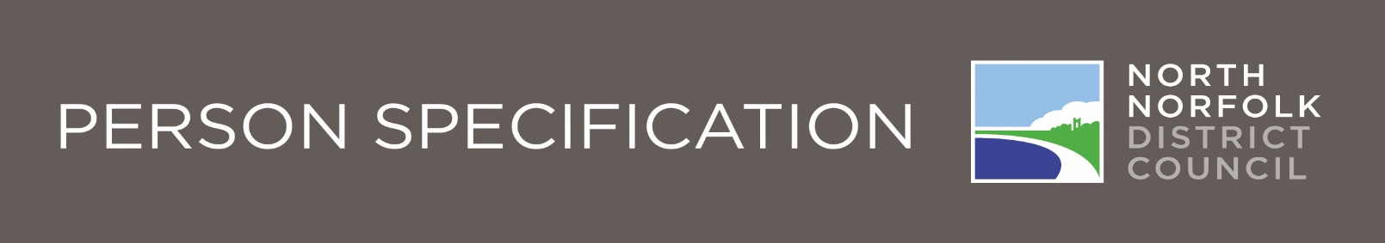

Team Leader - Development Management (Post 2144, 2120, 2211)
 |  | Essential | Desirable | How  Identified
Knowledge and Experience | Demonstrates professional knowledge and understanding of planning policy and development management. |  |  | Application Form* / Interview
 | Demonstrates a wide understanding and knowledge of Local Government. |  |  | Application Form* / Interview
 | Experience of working within a busy development management environment |  |  | Application Form* / Interview
 | Demonstrates good staff management skills and good understanding of performance management |  |  | Application Form* / Interview
 | Demonstrates a good knowledge of Health and Safety legislation as it affects the Council staff. |  |  | Application Form* / Interview
Qualifications | Educated to Degree level or equivalent |  |  | Application Form
Qualifications | Membership of the RTPI |  |  | Application Form
Qualifications | Level 4 qualification in management or equivalent |  |  | Application Form
Qualifications | Qualified to drive |  |  | Application Form

Team Leader - Development Management (Post 2120)
 |  | Essential | Desirable | How  Identified
Skills | Management and team leadership skills including the adoption of an approachable style of management and to develop, encourage and motivate staff. |  |  | Application Form* / Interview
Skills | Good judgement and decision making skills. |  |  | Application Form* / Interview
Skills | Time management skills |  |  | Interview
Skills | Good numeracy skills |  |  | Application Form* / Interview
Skills | Good interpersonal and negotiation skills, including ability to use tact and diplomacy |  |  | Application Form* / Interview
Skills | Interpretation skills in relation to complex plans and technical supporting documents. |  |  | Application Form* / Interview
Skills | Good written and verbal communication skills, including the ability to speak calmly and clearly, in sometimes confrontational situations. |  |  | Application Form* / Interview
Skills | Good IT skills including MS word and office |  |  | Application Form* / Interview
Skills | Good presentation skills |  |  | Application Form* / Interview
Skills | Delegation skills and ability to gauge, distribute and monitor workloads |  |  | Application Form* / Interview
Skills | Ability to problem solve and make timely and effective decision which arise. |  |  | Application Form* / Interview
Aptitude and  Disposition | Self aware |  |  | Interview
Aptitude and  Disposition | Confident and assertive, and resilient |  |  | Interview
Aptitude and  Disposition | Articulate |  |  | Interview
Aptitude and  Disposition | Ability to use initiate to solve problems |  |  | Interview
Aptitude and  Disposition | Ability to juggle competing demands and workload. |  |  | Interview
Aptitude and  Disposition | Ability to work under own initiative |  |  | Interview
Personal  Circumstances | Flexible and able to attend meetings out of normal working hours |  |  | Application Form*
Personal  Circumstances | Has daily access to personal transport |  |  | Application Form*
Personal  Circumstances | Ability to carry out site visits and inspections |  |  | Application Form* / Interview

Our Values and Behaviours
The values and behaviours we seek from our staff draw on the high standards of the Council:
Fairness - We respect people and treat everyone fairly
Ambition - We welcome new challenges and embrace change
Integrity - We are open and honest and listen
Resourcefulness - We strive to be efficient with our resources

