

Economic Growth Manager (Post 2056)
Service Area
Sustainable Growth
Manager/Team Leader
Assistant Director for Sustainable Growth
Direct reports
3
Total Managed
3
Purpose of the Role

To develop and implement procedures, strategies, projects and other initiatives that support economic growth within the district, in accordance with the Corporate Plan. Developing and operating approaches which support existing business activity; assist in the development of new businesses; and promote investment. To work in partnership with organisations and local businesses and access sources of external funds where appropriate.

To manage the Council’s economic development functions, through a mixture of internal staff and resources and arrangements with external organisations. This includes developing, implementing, monitoring and reviewing:
- Economic development and business support
- Promotion, inward investment and regeneration activities
- Business engagement procedures

Key Result Areas

- To support the delivery of economic growth through the development of economic development strategies, draw down of external funding, business support and regeneration projects.

- To manage the economic growth service; including resource allocation, programme development and project planning; recruitment, training and development of staff; and the development of policies and procedures (by reference, as appropriate, to Cabinet, Overview and Scrutiny Committee and CLT).

- To manage economic development and business support initiatives, including these undertaken with external funding, and to manage the administration of the Council’s own funding support schemes as appropriate
- To liaise closely with businesses or consortia of organisations representing economic growth opportunities wishing to bring economic development, growth or investment into the area and to help meet their needs as appropriate by liaising with relevant Council services (in particular, Planning, environment health, Climate Change and Environment) and external partners.

- To represent the Council on internal and external committees and partnerships and support partnership working where this ‘adds value’ through joint strategic planning and/or project management and to access funding opportunities to promote economic growth initiatives.

- To use and analyse empirical data in planning and project development and oversee the effective management and delivery of initiatives which have been prioritised by the Council.
- To prepare service plans and support the implementation of a performance framework for the Council and its partner organisations and to respond to correspondence relating to the operation of the service.
- To ensure that related budgets are planned and expenditure monitored in line with corporate and service requirements.
- To ensure all activities are supported by written processes which assist in the delivery of high-quality service-related outcomes, ensuring there is a clear audit trail to support all decisions and procurement of services

- To ensure all contractors and suppliers maintain the Council’s requirements and standards relating to Health and Safety and Equalities and Diversity practice, together with any other relevant responsibilities required by law.
- To ensure all employees are managed in accordance with the Council’s employment policies and that employee development is planned to meet the needs of both the Council and the service. To ensure the Council’s Performance Appraisal Scheme is operated effectively, and all related activities are completed as required by corporate appraisal cycle.
- To promote and adhere to the workplace values of our organisation.

- Prioritise health and safety in the workplace, ensuring personal adherence and the safety of others affected by workplace actions.

- Any other work required and as directed within the confines of the existing grade of the post.

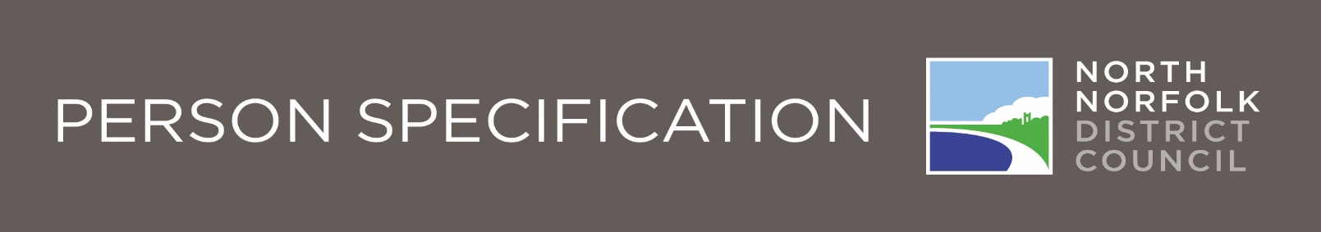

(Economic Growth Managers 2056)
 |  | Essential | Desirable | How  Identified
Knowledge and Experience | A good understanding of the national and local growth policy context and its influences |  |  | Application form
Knowledge and Experience | Experience and knowledge of economic development, funding and developing regeneration projects |  |  | Application form
Knowledge and Experience | Experience of developing and leading project teams, procurement and contract management |  |  | Application form
Knowledge and Experience | Experience of working in local government |  |  | Application form
Knowledge and Experience | Experience of developing and building partnerships with a range of stakeholders |  |  | Application form
 | An understanding of the wider development planning and policy framework |  |  | Application form
 | Experience in managing professional staff outside own discipline |  |  | Application form
 | Experience and understanding of financial management and administration |  |  | Application form
 | Knowledge of regulatory processes |  |  | Application form
Qualifications | Qualified to degree level in relevant subject |  |  | Application form
Qualifications | Management qualification or demonstrable experience of managing staff |  |  | Application form
Qualifications | Post graduate professional qualification in relevant profession |  |  | Application form
Qualifications | Member of an appropriate professional institute |  |  | Application form
Qualifications | Qualified to drive |  |  | Application form

 |  | Essential | Desirable | How  Identified
Skills | Excellent communication skills |  |  | Application form/ Interview
Skills | Excellent people management skills |  |  | Application form/ Interview
Skills | Good project management skills |  |  | Application form/ Interview
Skills | Stakeholder relationship management skills |  |  | Application form/ Interview
Skills | Good analytical skills |  |  | Application form/ Interview
Skills | Able to manage a range of conflicting and competing priorities |  |  | Application form/ Interview
Skills | Good numeracy skills |  |  | Application form/ Interview
Skills | Good IT skills |  |  | Application form/ Interview
Skills | Ability to demonstrate innovation and initiative and be a self-starter |  |  | Application form/ Interview
Skills | Tact and diplomacy in dealing with public stakeholders and high degree of political acumen. |  |  | Application form/ Interview
Aptitude and  Disposition | Has a ‘can do’ outlook |  |  | Interview
Aptitude and  Disposition | Team centered |  |  | Interview
Aptitude and  Disposition | Able to work with other disciplines |  |  | Interview
Aptitude and  Disposition | Able to work unsupervised |  |  | Interview
Aptitude and  Disposition | Self-motivated |  |  | Interview
Personal  Circumstances | Has the use of personal transport |  |  | Application form
Personal  Circumstances | Able to work outside of normal office hours |  |  | Application form
Personal  Circumstances | Sufficient mobility to undertake site visits |  |  | Application form

Our Values and Behaviours
The values and behaviours we seek from our staff draw on the high standards of the Council:
Fairness - We respect people and treat everyone fairly
Ambition - We welcome new challenges and embrace change
Integrity - We are open and honest and listen
Resourcefulness - We strive to be efficient with our resources

