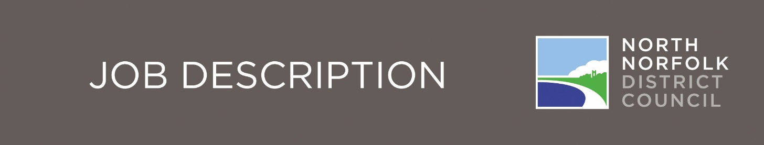

Graphic Designer (Post 1280)

Service Area
Communications

Manager/Team Leader
Assistant Director for Corporate Services and Transformation

Direct reports
N/A

Total Managed
N/A

Purpose of the Role
To create quality promotional digital and print material and to advise and guide Council staff and members on graphic design.

Key Result Areas

- To assist in the promotion and visual presentation of the Council and its services among its target audiences.
- Create a wide range of visually appealing and accurate promotional material on behalf of all Council service areas.
- To design and publish brochures, leaflets, posters, web banners and other digital graphics, display boards, forms and documents.
- To provide engaging graphics/infographics to support the Council’s commitment to increased digital and video content.
- Help maintain the Council’s corporate branding.
- Provide specialist professional advice in design and layout and to support the promotional needs of individual services within the Council.
- Work closely with the Communications and PR Manager as well as all stakeholder groups including all Council departments to define priorities, manage workload and avoid the need to outsource graphic design where possible.
- To administer the design service including billing of internal customers and monitoring income and expenditure.
- Ensure all related projects are delivered on time and within budget.
- To take reasonable care for the Health and Safety of yourself and other persons who may be affected by your actions.
- Any other work required and as directed within the confines of the existing grading of the post.

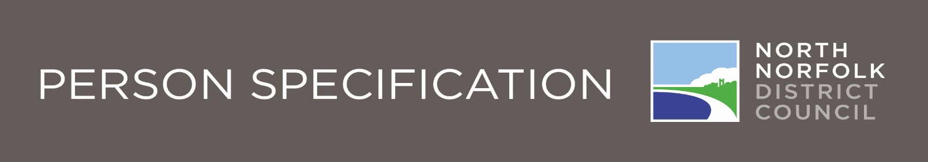
Graphic Designer (Post 1280)
 |  |  | Essential |  | Desirable |  | How  Identified
Knowledge and Experience | Previous employment in a professional design/communications environment |  |  |  |  |  | Application Form*
 | Comprehensive knowledge of leading graphic design applications including but not limited to the full Adobe suite of software |  |  |  |  |  | Appl Form/  Interview*
 | Understanding of web accessibility guidelines |  |  |  |  |  | Appl Form/  Interview*
 | Portfolio of online and print graphic design material that you have worked on |  |  |  |  |  | Application Form*
Qualifications | Graphic design or similar art and design degree level qualification. |  |  |  |  |  | Application  Form*
Qualifications | Qualified to drive |  |  |  |  |  | Application Form*
Training | Keeps up to date on graphic design changes / new technology to enhance Council’s graphic design capabilities |  |  |  |  | Application
Skills | Proficient in IT including Microsoft packages |  |  |  |  | Application Form*
Skills | Comprehensive knowledge of the full Suite of Adobe software |  |  |  |  | Application form*
Skills | Good communication skills (written and verbal) |  |  |  |  | Interview / Test*
Skills | Ability to multi-task with several projects running simultaneously |  |  |  |  | Interview
Skills | Presentation skills |  |  |  |  | Interview
Skills | Ability to prioritise and manage own workload and key stakeholder relationships |  |  |  |  | Application form*
Skills | Good interpersonal and customer care skills |  |  |  |  | Application form*

Graphic Designer (Post 1280)
 |  | Essential |  | Desirable | How  Identified
Aptitude and  Disposition | Self confidence |  |  |  | Interview
Aptitude and  Disposition | ‘Can do’ attitude |  |  |  | Interview
Aptitude and  Disposition | Awareness of personal impact upon others |  |  |  | Interview
Aptitude and  Disposition | Understanding of target audiences |  |  |  | Interview
Aptitude and  Disposition | Time management and managing priorities |  |  |  | Interview
Aptitude and  Disposition | Self-motivated |  |  |  | Interview
Personal  Circumstances | Has access to transport on a daily basis |  |  |  | Application Form*
Personal  Circumstances | Able to work outside normal working hours |  |  |  | Application Form*

Our Values and Behaviours
The values and behaviours we seek from our staff draw on the high standards of the Council:
Fairness - We respect people and treat everyone fairly
Ambition - We welcome new challenges and embrace change
Integrity - We are open and honest and listen
Resourcefulness - We strive to be efficient with our resources

